  Networking Logbook 2  [Document subtitle] | Unit Outcomes  Successful completion of the following logbook will contribute to the completion of the following outcomes:  - J0HJ 34 Computer Networking: Concepts, Practice and Introduction to Security – Outcome 2 & Outcome 4  West Lothian College  HNC Cyber Security

Section 1: Create a client server switched local area network, with secure endpoints

Scenario – You have been tasked with the setting up and configuring of a small local area network. This network should be set up with an emphasis on securing the endpoints of the network. To comply with this requirement, you can choose any suitable network operating system. You should be provided with suitable working hardware to allow this task to be completed.

Stage 1 – Select a suitable contemporary network topology
Star topology was chosen as its easy to manage and troubleshoot, it is scalable, reliable and is centralized control allowing full control of all network traffic. This is mainly used for home networks, office LANS and hospitals which highlights that this is suitable.

Stage 2 – Devise a suitable naming convention for the hosts/nodes
Domain: CCServer.com
Server Name CCServer1
Client: CCTest1 cc.

Stage 3 – Devise a suitable logical addressing structure for the network hosts/nodes
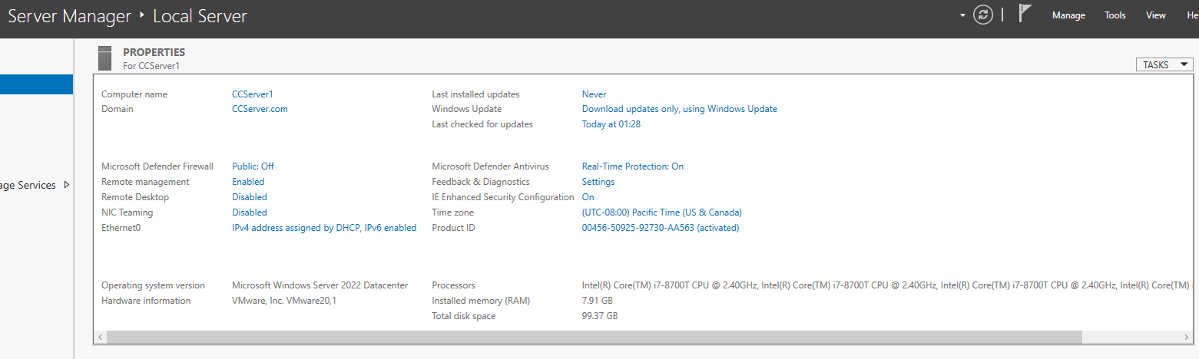

Stage 4 – Configure appropriate network authentication services and name resolution
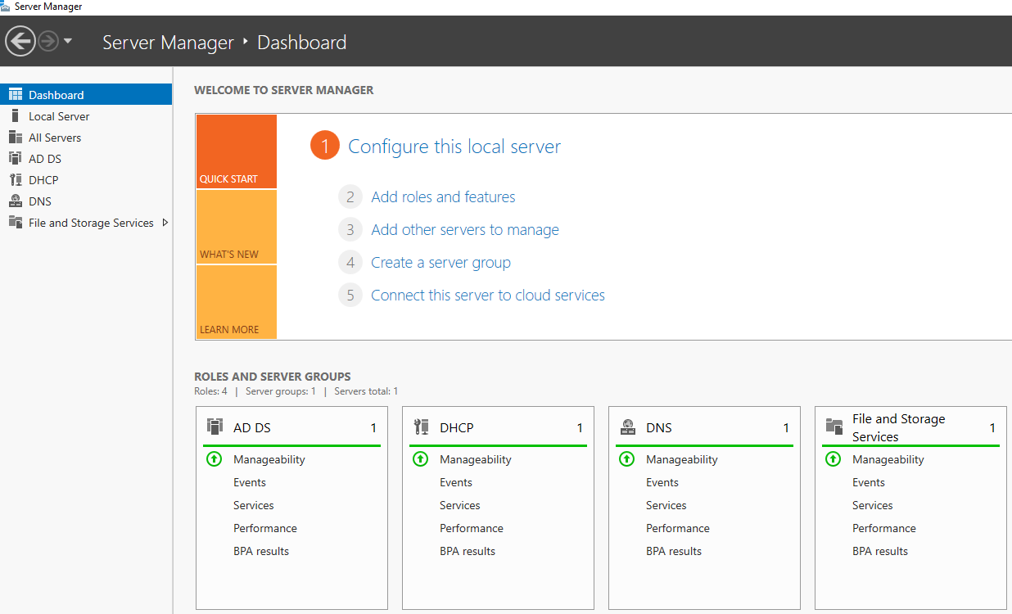

Stage 5 – Using the addressing scheme provided at stage 3, implement network DHCP services within the LAN


Stage 6 – Harden the endpoints devices/hosts by installing virus checking software
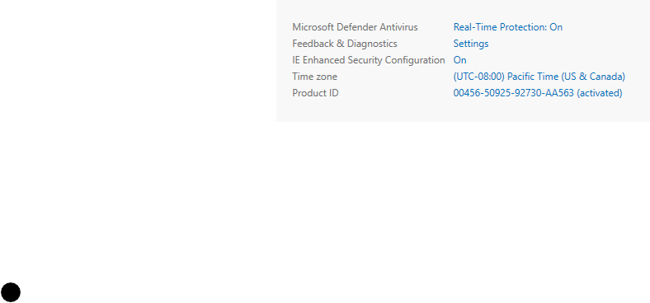

Stage 7 – Configure endpoint devices’ firewalls to allow network hosts to ping each other
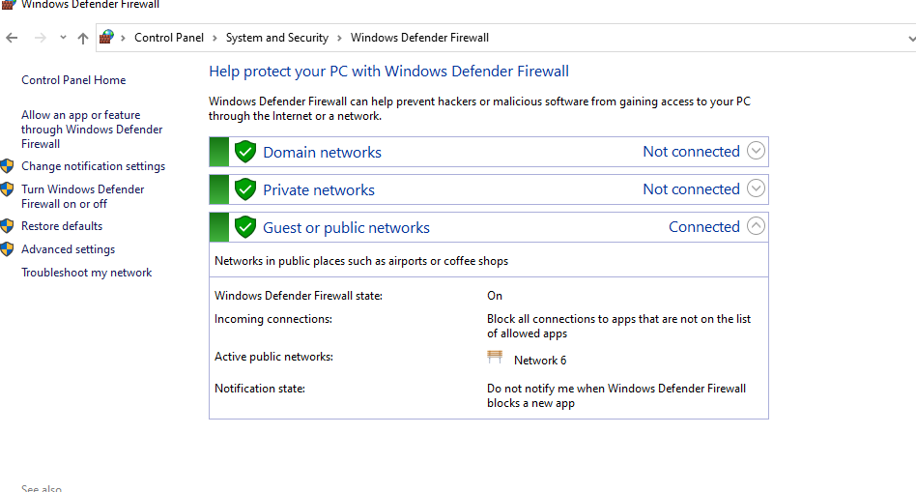

Stage 8 – Show evidence that stages 4-7 have been completed and are operational
As shown in the above images, the system is completed and operational

Section 2: Capture the transmitted received data using network sniffer technology
Scenario – You have been asked to prove how DHCP operates and how some protocols can be considered more secure than others
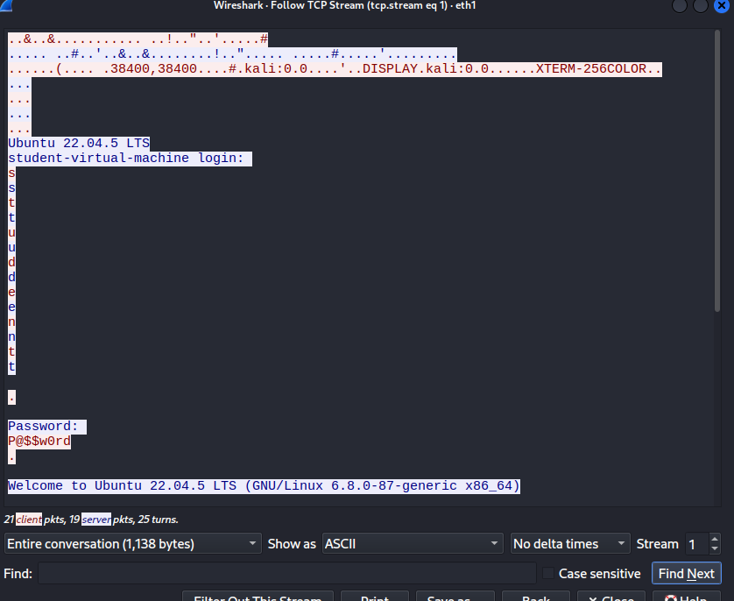

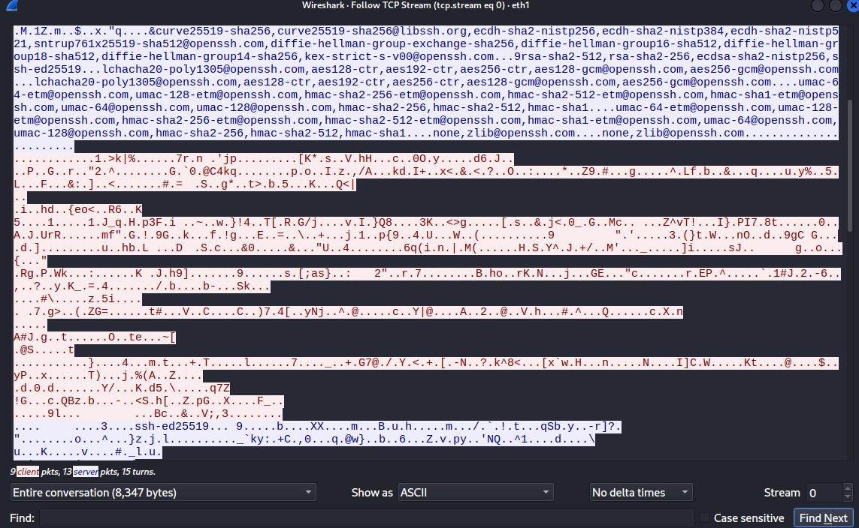
The following screenshots displays the packet data during the login process of the Telnet and SSH server which shows the telnet packet data has far less than the SSH packet data

Stage 1 – DHCP
Using the network set up in Section 1, set up your network packet sniffer to capture and understand the DHCP communication process between the DHCP server and selected host.

Stage 2 – Telnet/SSH
You should have been provided with a suitable test environment which includes a Telnet and SSH Server. You should also have a login for each of the servers. Your task is to capture the packet data during the login process of each, and compare the results from each.

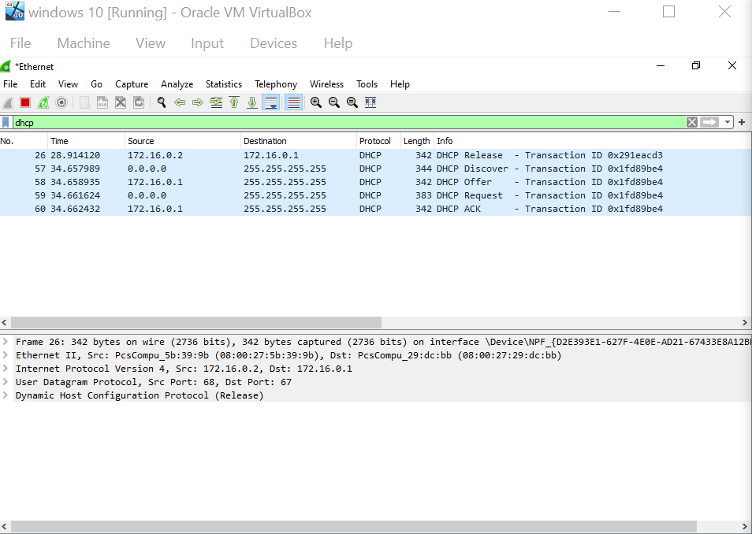

Student Checklist
Action | Complete?
Section 1 – Create a client server switched local area network, with secure endpoints
- Description of actions carried out as well as justifications of these and screenshots/screen recordings where appropriate
Section 2 – Capture the transmitted received data using network sniffer technology
- Descriptions of actions carried out as well as screenshots/ screen recordings where appropriate.

